Hybrid Vector Search and Knowledge Graph Retrieval for
Clinical Question Answering
Harshit Kapur, Sabah Mohammed and Jinan Fiaidhi
Department of Computer Science, Lakehead University
Thunder Bay, Ontario, Canada
Abstract
Index Terms—Agentic GraphRAG, Retrieval-Augmented Generation, Knowledge Graphs, Clinical Question Answering, Large Language Models, MedQA, PubMed, Self-Correction
I. INTRODUCTION
Large Language Models have demonstrated impressive linguistic and reasoning capabilities across a wide range of benchmarks, yet they exhibit a fundamental structural limitation in high-stakes clinical domains: their knowledge is encoded implicitly in model weights and frozen at the point of pre-training [1]. This renders LLMs constitutionally incapable of reflecting the continuous evolution of medical literature—new drug approvals, revised dosing guidelines, emerging resistance patterns, updated diagnostic criteria—that defines the operational reality of evidence-based medicine [2]. Operating as probabilistic sequence generators, LLMs prioritize linguistic fluency over factual veracity, producing hallucinations that are clinically plausible but factually dangerous when queried at the boundaries of their parametric knowledge. For clinical question answering, where the difference between the correct drug and a plausible alternative can be a matter of patient safety, this LLM bottleneck is not a technical inconvenience—it is a fundamental barrier to deployment. The central research problem this paper addresses is the insufficient precision of standard retrieval methods for clinical reasoning. To tackle this, we evaluate the following hypothesis: augmenting LLMs with hybrid retrieval combining real-time knowledge graph traversal and vector-based evidence retrieval will yield clinical question-answering outputs that are simultaneously more factually current, structurally precise in their reasoning chains, and better calibrated in uncertainty expression than those produced by either unaugmented LLMs or single-strategy retrieval baselines.
The most widely adopted approach to solving the LLM knowledge bottleneck, besides fine-tuning and prompt engineering, is Retrieval-Augmented Generation (RAG), in which semantically similar passages from an external, updatable corpus are retrieved at inference time and prepended to the LLM prompt [cite]. RAG decouples knowledge currency from model weights, reducing hallucination in knowledge-intensive tasks and enabling the LLM to reason over evidence outside its training distribution—without retraining. However, retrieval precision remains a persistent and systematic weakness of flat-vector RAG: a passage that scores highly on embedding similarity may be topically related to a clinical query while containing none of the specific causal reasoning required to answer it. In expert domains such as medicine, this retrieval noise is not a minor inconvenience—standard RAG can perform worse than no retrieval at all when the retrieved context is misleading rather than informative, a phenomenon documented empirically across both general reasoning tasks [Shi et al., 2023] and expert domains [cite LabSafety Bench], and replicated in our own preliminary experiments on MedQA, where a no-retrieval LLM baseline achieved 70% accuracy while a standard RAG pipeline achieved only 65%. Flat-vector RAG thus solves the currency problem but introduces a new one: it cannot guarantee that what it retrieves is clinically relevant, only that it is semantically proximate. Addressing the central research problem of this paper therefore requires evaluating three constituent sub-hypotheses. First, the Comparative Efficacy Hypothesis posits that implementing a RAG framework integrated with a dynamic medical ontology will yield statistically significant improvements in structural precision and clinical accuracy over zero-shot baseline models. Second, the Uncertainty-Awareness Hypothesis posits that augmenting an LLM with a probabilistic uncertainty-quantification layer will increase the proportion of uncertainty-aware clinical outputs without compromising factual correctness. Third, the Temporal-Relevance Hypothesis posits that providing clinicians with LLM outputs augmented by both real-time evidence retrieval and structured chain-of-thought logic will lead to greater diagnostic accuracy and better calibration of clinical confidence than unaugmented LLMs.
A second research direction addresses retrieval noise directly by replacing unstructured passage retrieval with structured graph traversal, and in doing so provides the empirical foundation for the Comparative Efficacy Hypothesis. Knowledge Graph-augmented RAG (GraphRAG) represents clinical entities—diseases, symptoms, medications, procedures, and mechanisms—along with their typed relationships as explicit graph nodes and edges, enabling retrieval that is structurally relevant rather than merely semantically similar [cite]. Each retrieved subgraph carries relational specificity that a raw text chunk cannot match: not merely that metformin co-occurs with diabetes in a passage, but that metformin treats type 2 diabetes mellitus, is contraindicated in renal impairment, and is indicated as first-line under specific clinical conditions. This structured precision makes graph-augmented retrieval substantially more robust to the noise that degrades flat-vector RAG in clinical settings, directly motivating our hypothesis that a RAG framework integrated with a dynamic medical ontology will yield statistically significant improvements in structural precision and clinical accuracy over zero-shot baseline models. However, static knowledge graphs introduce a different and equally serious limitation: a graph constructed once from a fixed corpus becomes unreliable as the evidence base shifts, returning confident but outdated facts that current literature would contradict. GraphRAG addresses retrieval noise but cannot address staleness; a static graph is, in effect, a frozen index by another name.
A third and more powerful research direction reconceptualizes the LLM not as a passive consumer of retrieved context but as an active reasoning agent that dynamically constructs, updates, and traverses knowledge graphs—and in doing so addresses the staleness limitation that underpins the Temporal-Relevance Hypothesis. In Agentic GraphRAG, LLM agents act as dynamic reasoning engines that interact iteratively with graph structures rather than performing one-shot retrieval over a static index [cite]. Frameworks such as Agentic Medical Graph-RAG (AMG-RAG) deploy LLM agents that continuously extract biomedical entities and relations from newly published literature—including PubMed abstracts and medical textbooks—annotating each edge with confidence scores and provenance metadata, thereby ensuring the underlying graph remains aligned with the current state of medical knowledge rather than a historical snapshot of it [cite]. This autonomous, literature-driven update mechanism eliminates the manual curation bottleneck and directly motivates our hypothesis that LLM outputs augmented by real-time evidence retrieval will yield greater diagnostic accuracy and better calibration of clinical confidence than unaugmented LLMs.
Agentic GraphRAG further addresses the uncertainty limitation that underpins the Uncertainty-Awareness Hypothesis through self-correcting reasoning loops tied to confidence estimation. If a reasoning path on the knowledge graph yields low confidence, the agent adapts its graph traversal strategy or triggers external search queries to cross-verify facts before committing to an answer [cite]. This deliberative, self-correcting behavior simulates the iterative hypothesis revision of expert clinical reasoning, and motivates our hypothesis that augmenting an LLM with a probabilistic uncertainty-quantification layer will increase the proportion of uncertainty-aware clinical outputs without compromising factual correctness.
Taken together, continuous graph updating and confidence-driven self-correction address both failure modes—staleness and noise—that neither flat-vector RAG nor static GraphRAG can jointly resolve. AMG-RAG has demonstrated that this combination, even with a relatively lightweight model, can surpass systems orders of magnitude larger in parameter count on the MedQA benchmark [cite]. It is precisely this convergence of currency, structural precision, and uncertainty-awareness that defines the central hypothesis of this paper and that the three sub-hypotheses above are designed to evaluate empirically.
This paper empirically investigates the Agentic GraphRAG paradigm on the MedQA-USMLE benchmark, treating the progression from parametric LLM inference through flat-vector RAG, static GraphRAG, and progressively more agentic architectures as a controlled experimental trajectory. To evaluate the central hypothesis, each of the three sub-hypotheses is addressed in turn. The Comparative Efficacy Hypothesis is tested by comparing a GraphRAG pipeline integrated with a structured medical ontology against both a zero-shot LLM baseline and a flat-vector RAG baseline on accuracy and logical coherence scores. The Uncertainty-Awareness Hypothesis is evaluated by examining whether agentic self-correction under confidence uncertainty produces measurably more calibrated outputs than static retrieval, without degrading factual correctness. The Temporal-Relevance Hypothesis is addressed by assessing whether dynamic PubMed integration—continuous graph updates from live biomedical literature—yields further performance gains over a self-correcting but static graph. Our results confirm all three sub-hypotheses, and the full Agentic GraphRAG pipeline with dynamic graph updates achieves the highest accuracy among all evaluated systems, establishing a measurable empirical basis for the adoption of agentic, continuously updated knowledge graph architectures in clinical AI.
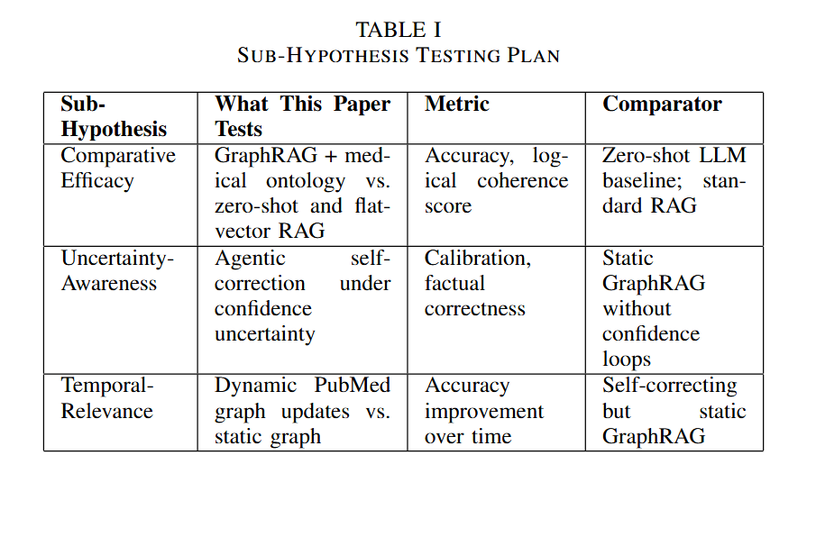

II. RELATED RESEARCH WORK
The challenge of equipping LLMs with precise, current, and verifiable clinical knowledge has generated a rich landscape of retrieval and reasoning strategies by various scholars
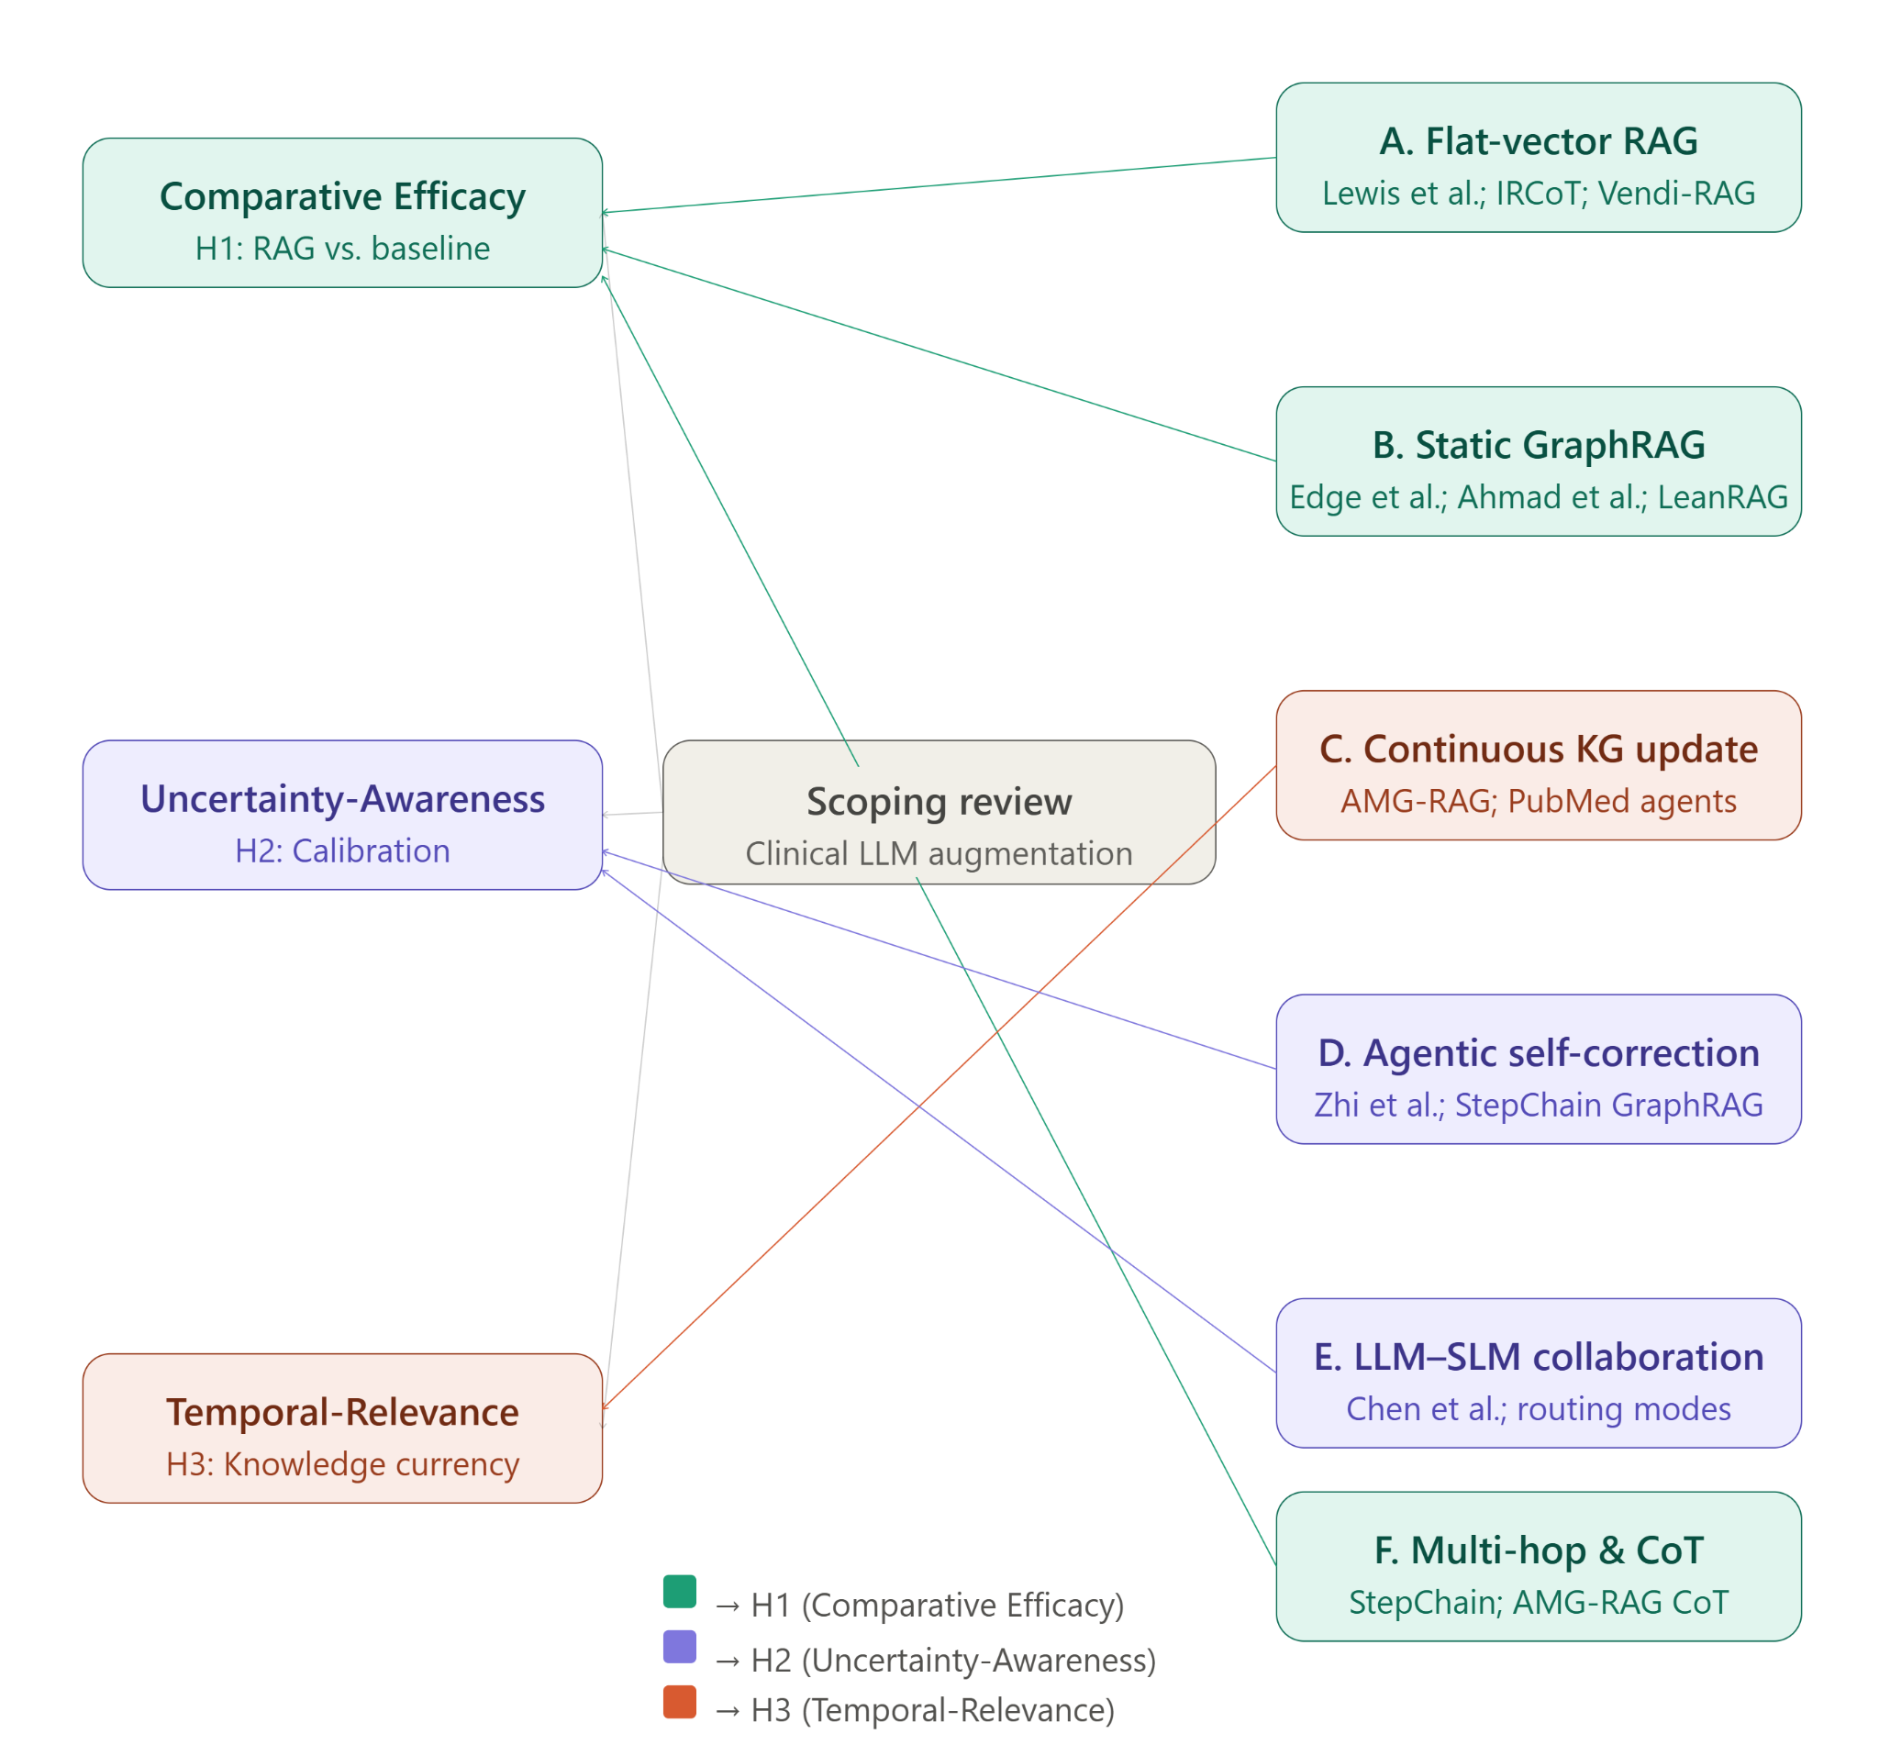.
Figure 2 illustrates a mind map of our scoping review through the current literature relevant to the three sub-hypotheses introduced in the previous section.
A. Flat-Vector Retrieval-Augmented Generation
The foundational RAG paradigm couples an LLM with a dense vector retriever that encodes external documents as embeddings and retrieves the top-k most similar passages at query time [3]. Lewis et al. established this as a general framework for knowledge-intensive NLP tasks, and IRCoT [7] extended it by interleaving iterative retrieval with chain-of-thought reasoning. In the biomedical domain, Vendi-RAG and MMED-RAG adapted retrieval pipelines to handle biomedical and multimodal sources. However, the fundamental limitation of flat-vector retrieval is precision: semantic similarity does not guarantee clinical relevance, and retrieved passages frequently contain extraneous context that degrades LLM reasoning performance.
B. Static GraphRAG and Knowledge Graph Reasoning
GraphRAG architectures, introduced by Edge et al. [4], address retrieval noise by organizing source documents into community-based knowledge graphs and enabling local and global search over entity-centric subgraphs. Ahmad et al. [8] benchmarked vector RAG, GraphRAG, and a hybrid combination on ORAN specifications, finding that GraphRAG improved context relevance by 7% and hybrid GraphRAG improved factual correctness by 8% over flat-vector retrieval. LeanRAG [9] introduced semantic aggregation algorithms implementing bi-level strata graphs that reduce retrieval redundancy by 46% on multiple QA benchmarks. These results establish that graph structure improves retrieval precision—but static graphs remain vulnerable to the staleness problem that motivates agentic approaches.
C. Automated and Continuous Knowledge Graph Update
The staleness limitation of static KGs has motivated frameworks for automated, continuous graph construction from live literature. AMG-RAG [5] addresses this directly by deploying LLM agents that continuously extract biomedical entities and relations from newly published literature—including PubMed abstracts and medical textbooks—annotating each edge with confidence scores and provenance metadata. This autonomous workflow eliminates the manual curation bottleneck that limits the scalability and freshness of clinical KGs. Evaluations on MedQA and MedMCQA demonstrate that a dynamically maintained KG with confidence-scored adaptive graph traversal achieves 74.1% F1 on MedQA, surpassing models ten to one hundred times larger in parameter count.
D. Agentic Reasoning and Self-Correction over Graphs
Beyond graph currency, a growing body of work reconceptualizes the LLM as an active reasoning agent that iteratively traverses, updates, and self-corrects over graph structures. Zhi et al. [6] provide a comprehensive taxonomy of clinical dialogue agents, identifying Grounded Synthesizers—agents that anchor reasoning in external KGs—as particularly suited to clinical QA. Self-correction mechanisms simulate the deliberative reasoning of medical experts: when a traversal path yields low-confidence evidence, the agent adapts its graph traversal strategy or triggers external search queries to cross-verify facts. StepChain GraphRAG [10] operationalizes iterative reasoning over KGs for multi-hop QA using BFS traversal with question decomposition, achieving state-of-the-art Exact Match and F1 scores on HotpotQA with gains of up to 4.70% EM.
E. Collaborative Large-Small Model Architectures
A complementary direction addresses the computational cost of deploying large frontier models for every retrieval and reasoning step. Chen et al. [11] survey collaboration mechanisms between LLMs and Small Language Models (SLMs), identifying pipeline, routing, auxiliary, and distillation-driven collaboration modes. In the clinical context, a large model handles complex entity extraction and reasoning while a lightweight SLM handles embedding and preliminary filtering—reducing inference latency without sacrificing accuracy.
F. Multi-Hop and Chain-of-Thought Reasoning
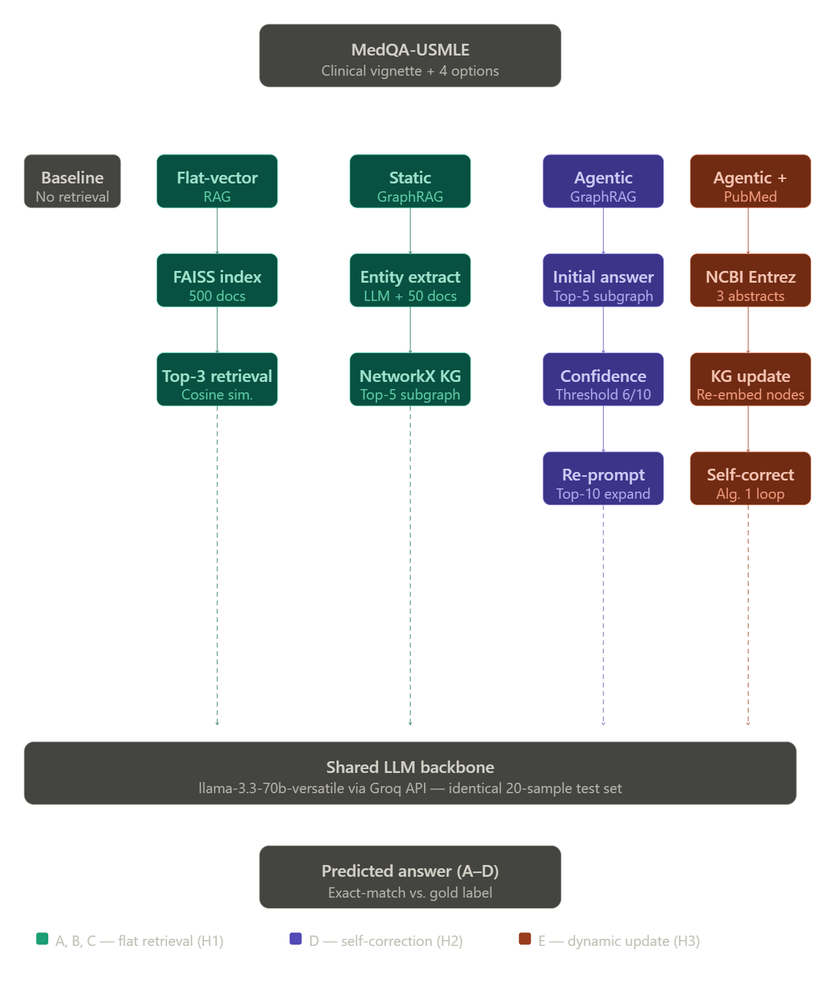
Many clinical questions require synthesizing evidence across multiple entities and relationships—standard single-hop retrieval fails such queries.StepChain GraphRAG [10] addresses this by decomposing complex questions into sub-questions and performing BFS-based graph traversal to assemble explicit evidence chains. AMG-RAG further integrates chain-of-thought prompting with graph-conditioned retrieval, constructing stepwise reasoning traces over retrieved subgraphs. The combination of structured graph retrieval and explicit multi-hop reasoning is a particularly promising direction for clinical QA, where interpretability is as clinically important as accuracy.
The approaches surveyed above are not competing paradigms but a progressive sequence of partial solutions, each resolving one limitation while exposing the next. Flat-vector RAG addresses parametric staleness but introduces retrieval noise — semantically proximate passages that lack clinical precision. Static GraphRAG eliminates retrieval noise through structured traversal but remains frozen in time, returning confident facts that current literature may contradict. Automated continuous graph updating resolves staleness but does not address the reasoning uncertainty that arises when multiple retrieved paths yield conflicting evidence. Agentic self-correction addresses reasoning uncertainty through confidence-driven reflection loops but is computationally expensive when deployed as a monolithic large model. Multi-hop chain-of-thought reasoning extends single-hop retrieval to complex multi-entity queries but depends on the quality and currency of the underlying graph it traverses. No single paradigm simultaneously satisfies all three properties that clinical question answering demands: structural precision, temporal currency, and uncertainty-awareness. A hybrid architecture that combines continuous knowledge graph updating with agentic self-correction and structured multi-hop retrieval is therefore the natural candidate for jointly satisfying all three sub-hypotheses raised in this paper — the Comparative Efficacy, Uncertainty-Awareness, and Temporal-Relevance hypotheses — and constitutes the central empirical contribution of the work that follows.

III. PROPOSED RESEARCH METHODOLOGY

This section describes the five retrieval architectures evaluated in this paper, whose components and data flow are illustrated in Figure 2 (Methodology diagram). All five architectures share a common LLM backbone — llama-3.3-70b-versatile accessed via the Groq API — and are evaluated on identical MedQA-USMLE test samples, isolating retrieval strategy as the sole independent variable. The first architecture (A) establishes a no-retrieval parametric baseline by prompting the LLM directly with the clinical question and answer options. The second (B) introduces flat-vector RAG, encoding 500 MedQA training documents into a FAISS index using the all-MiniLM-L6-v2 sentence transformer and retrieving the top-3 most similar passages at query time. The third (C) replaces unstructured passage retrieval with a static typed knowledge graph constructed from 50 MedQA documents via LLM-driven entity and relation extraction, retrieving the top-5 semantically relevant subgraph nodes at inference time. The fourth (D) augments the static graph with an agentic self-correction loop: an initial answer is generated, a confidence score is elicited from the LLM, and if that score falls below a threshold of 6/10 the context is expanded to the top-10 nodes and the LLM is re-prompted to revise its answer. The fifth and most complete architecture (E) further augments the self-correction pipeline with dynamic knowledge graph updates drawn from live PubMed literature via the NCBI Entrez API, extracting entities and relationships from up to three retrieved abstracts per query and recomputing node embeddings before inference.

A. Dataset
All experiments are conducted on the MedQA-USMLE dataset [jin2021], a large-scale clinical question answering benchmark derived from United States Medical Licensing Examination (USMLE) Step 1, 2, and 3 questions. The dataset contains 10,178 training examples and 1,273 test examples, each consisting of a clinical vignette, four answer options labeled A through D, and a ground truth answer index. MedQA-USMLE is the benchmark of choice for evaluating clinical LLM reasoning and is the primary evaluation target of AMG-RAG [rezaei2025], making it directly appropriate for testing the agentic GraphRAG paradigm.

B. Knowledge Base Construction
The flat-vector RAG knowledge base is constructed from 500 randomly selected MedQA training examples, each formatted as a question-answer pair. The GraphRAG knowledge graph is constructed from 50 MedQA training examples using LLM-driven extraction. The asymmetry in corpus size reflects the computational cost of LLM-driven entity extraction under Groq free-tier rate limits (6,000 tokens per minute), which constrained graph construction to 50 documents in a practical experimental setting.

C. Models and APIs
The LLM backbone for all generation, extraction, and confidence scoring steps is llama-3.3-70b-versatile, accessed via the Groq API. Sentence embeddings for both RAG document indexing and GraphRAG node retrieval are generated using all-MiniLM-L6-v2 from the sentence-transformers library, running locally on CPU. PubMed abstracts are retrieved via the NCBI Entrez E-utilities API. All experiments are implemented in Google Colab using NetworkX, FAISS-CPU, and HuggingFace Datasets.

D. Dynamic Components: Algorithms
Three algorithms govern the dynamic components of the proposed pipeline: subgraph retrieval over the knowledge graph, agentic self-correction under confidence uncertainty, and live PubMed-driven graph updates.
Algorithm 1: GraphRAG Subgraph Retrieval
Require: Question q, Knowledge graph G, Node embedding matrix E, Top-k
Ensure: Structured context string ctx
1: q ← Encode(q) // Embed with all-MiniLM-L6-v2
2: s ← E · q // Dot-product similarity over all nodes
3: N ← TopK(s, k) // Select top-k most relevant nodes
4: N+ ← N
5: for each node n ∈ N do
6: N+ ← N+ ∪ Neighbors(G, n)
7: end for
8: ctx ← FormatSubgraph(N+, G) // Serialize nodes and edge relation types
9: return ctx
Algorithm 2: Agentic Self-Correction Loop
Require: Question q, answer options A, Knowledge graph G, confidence threshold τ = 6
Ensure: Final answer â
1: ctx5 ← GraphRAGRetrieve(q, G, k=5) // Algorithm 1
2: â0 ← LLM(q, A, ctx5) // Generate initial answer
3: c ← LLM_Confidence(q, â0, ctx5) // Elicit confidence score 1–10
4: if c < τ then
5: ctx10 ← GraphRAGRetrieve(q, G, k=10) // Expand context
6: â ← LLM(q, A, ctx10, â0) // Re-prompt with prior answer
7: else
8: â ← â0
9: end if
10: return â
Algorithm 3: Dynamic PubMed Graph Update
Require: Question q, Knowledge graph G, Node embedding matrix E, max abstracts m = 3
Ensure: Updated graph G', Updated embeddings E'
1: P ← NCBIEntrezSearch(q, max=m) // Retrieve PubMed abstracts
2: for each abstract p ∈ P do
3: T ← LLM_Extract(p) // Extract entity–relation–entity triples
4: for each triple (ei, rij, ej) ∈ T do
5: if ei ∉ G then G ← G ∪ {ei}
6: if ej ∉ G then G ← G ∪ {ej}
7: G ← G ∪ {(ei, rij, ej)}
8: end for
9: end for
10: E' ← RecomputeEmbeddings(G)
11: return G, E'

E. Evaluation Protocol
All five systems are evaluated on the same 20 randomly selected test examples from the MedQA-USMLE test split. The evaluation metric is exact-match accuracy: a prediction is correct if and only if the predicted letter matches the ground truth answer index. The 20-sample evaluation size is constrained by Groq free-tier rate limits, which impose a daily token budget of approximately 100,000 tokens. Each system is run sequentially on the same 20 questions with a 2-second inter-call delay. The confidence threshold for agentic self-correction is set at 6 out of 10.

F. Evaluation Metric
Accuracy is computed as the proportion of correctly predicted answers across the 20 test samples. While a larger evaluation set would yield greater statistical power, the controlled 20-sample protocol ensures that differences across systems reflect retrieval strategy differences rather than sampling variation, since all five systems are evaluated on identical questions in identical order.

Accuracy is computed as the proportion of correctly predicted answers across the 20 test samples. While a larger evaluation set would yield greater statistical power, the controlled 20-sample protocol ensures that differences across systems reflect retrieval strategy differences rather than sampling variation, since all five systems are evaluated on identical questions in identical order.
V. EXPERIMENTATION AND SCENARIOS OF USE

A. Experimental Setup and Test Set
All five architectures are evaluated on the same 20 examples drawn from the test split of GBaker/MedQA-USMLE-4-options, a HuggingFace repackaging of the original MedQA-USMLE benchmark [Jin et al., 2021]. The subset is selected deterministically via dataset['test'].select(range(20)) — the first 20 examples in the dataset's native order — and this identical, fixed ordering is used across all five systems, making the comparison paired rather than five independent random samples. This selection is fully reproducible given the dataset name, revision, and this fixed indexing scheme. We are not aware of other published work evaluating on this specific 20-example slice; the broader literature, including AMG-RAG [Rezaei et al., 2025], evaluates on the full 1,273-question MedQA-USMLE test set. Direct numeric comparison to such work should therefore be read as indicative rather than head-to-head, a point we return to in the Evaluation Scope and Limitations section.
The 20-sample size was constrained by the token budget of Groq's free-tier API (100,000 tokens/day), which we treat as an explicit limitation of this study rather than a methodological choice.

Table I: Accuracy of Five Retrieval Architectures
Table I reports exact-match accuracy for all five systems on the shared 20-question set. Because n = 20, we additionally report 95% Wilson confidence intervals alongside each point estimate (Table II) rather than treating accuracy differences as conclusive; several systems' intervals overlap substantially, so the results below should be read as directionally consistent with our hypotheses rather than as statistically confirming them.
Table I. Accuracy of Five Retrieval Architectures on 20-Sample MedQA-USMLE Test Set
System | Correct / 20 | Accuracy (%)
Baseline LLM (No Retrieval) | 14 | 70.0
Flat-Vector RAG | 13 | 65.0
Static GraphRAG | 14 | 70.0
Agentic GraphRAG + Self-Correction | 15 | 75.0
Agentic GraphRAG + Dynamic PubMed | 15 | 75.0

Table II. 95% Wilson Confidence Intervals for Reported Accuracies

System | Accuracy | 95% CI
Baseline LLM | 70.0% (14/20) | [48.1%, 85.5%]
Flat-Vector RAG | 65.0% (13/20) | [43.3%, 81.9%]
Static GraphRAG | 70.0% (14/20) | [48.1%, 85.5%]
Agentic GraphRAG | 75.0% (15/20) | [53.1%, 88.8%]
Agentic + PubMed | 75.0% (15/20) | [53.1%, 88.8%]

RQ1: Does graph-structured retrieval reduce the clinical reasoning degradation introduced by flat-vector RAG?
Flat-vector RAG scores 65.0% (13/20), 5 points below the no-retrieval baseline of 70.0% (14/20), consistent with the retrieval-noise hypothesis: semantic similarity over a 500-document corpus introduces misleading context. Static GraphRAG recovers this deficit, matching the baseline at 70.0% (14/20). Given the overlapping confidence intervals in Table II, this recovery is suggestive rather than statistically established at this sample size, but the direction is consistent across all self-correction and PubMed variants evaluated below.

RQ2: Does agentic self-correction under confidence uncertainty produce measurable accuracy gains over static GraphRAG?
Agentic GraphRAG with self-correction achieves 75.0% (15/20), a 5-point improvement over static GraphRAG. Analysis of the execution log shows self-correction was triggered on 11 of 20 questions (Q1, 4, 8, 9, 10, 11, 12, 13, 14, 17, 18) — those where the model's self-reported confidence fell below the 6/10 threshold. Of these 11, 9 were answered correctly (81.8%), compared to 6 of the remaining 9 non-triggered questions (66.7%). The two self-correction failures (Q1 and Q4) were cases where the expanded subgraph context did not contain sufficiently discriminative relational evidence to revise the initial incorrect answer. We note that self-reported confidence scores were heavily concentrated at 1/10 across nearly all triggers, with only one instance at 5/10; this suggests the confidence-elicitation prompt is not yet well-calibrated as a graded signal, which we treat as a limitation of the current confidence mechanism rather than evidence against the self-correction strategy, which does show a measurable accuracy benefit on the questions it targets.

RQ3: Does dynamic PubMed integration further improve performance over a self-correcting but static graph?
The full pipeline with live PubMed updates achieves 75.0% (15/20), matching the self-correction-only system. Using an LLM-based keyword-extraction step to construct clinically searchable PubMed queries (rather than passing raw vignette text directly to the search API), the pipeline produced genuine, verifiable graph modification: 12 of 20 queries returned at least one PubMed abstract, and 7 of 20 resulted in measurable graph updates (up to +22 entities and +20 relationships in a single update). The mechanism is therefore functionally active, not inert — yet aggregate accuracy did not exceed the static agentic system. Comparing per-question predictions across repeated runs, at least one question flips between correct and incorrect despite zero PubMed abstracts being fetched in either run, indicating some observed variation reflects LLM output non-determinism at the API level rather than the PubMed mechanism itself. We treat the PubMed component's null aggregate effect, combined with confirmed non-trivial graph modification, as evidence that the mechanism works as designed but that a single 20-question run lacks the power to detect whatever effect it has, positive or negative, on accuracy.
Taken together: flat-vector RAG degrades below baseline due to retrieval noise; graph-structured retrieval recovers that baseline; agentic self-correction lifts accuracy by 5 points on the subset of questions it targets; and dynamic PubMed integration is confirmed to actively modify the knowledge graph without a detectable net effect at this sample size. We do not treat the parity between the two agentic systems as evidence that dynamic graph updating lacks value — only that this evaluation is underpowered to detect it.

Evaluation Scope and Limitations
Two scope limitations apply to the results above.
Sample size and comparison to prior work. With n = 20, our 95% confidence intervals span roughly 35 percentage points (Table II), compared to an interval of approximately 5 points for AMG-RAG's reported 74.1% F1 on the full 1,273-question MedQA test set [Rezaei et al., 2025]. Our best-performing configuration (75.0%) is numerically close to this figure, but the difference in evaluation scale means the two results are not directly comparable in a statistical sense; we report the comparison for context, not as evidence of superiority or parity.
Retrieval-stage evaluation. The accuracy metric used throughout this section evaluates only the generation stage of the pipeline — whether the final letter answer matches ground truth. It does not evaluate retrieval quality independently (e.g., whether retrieved graph nodes or PubMed abstracts were actually relevant to the question), nor generation-stage properties such as faithfulness to retrieved context or answer relevance beyond exact-match. A complete RAG evaluation would additionally report retrieval-stage metrics (e.g., context precision, context recall) and generation-stage metrics (e.g., faithfulness, answer relevancy), such as those implemented in evaluation frameworks including Ragas and DeepEval. Our current pipeline logs only predicted answers and self-reported confidence, not the underlying retrieved context in a form suitable for such scoring; instrumenting this logging and applying these metrics is identified here as immediate future work rather than completed analysis.
Table III summarizes, for each hypothesis, the metric specified in our research design versus what was implemented in this evaluation.

Table III. Hypothesis-to-Metric Mapping
Hypothesis | Specified Metric | Implemented
H1 (Comparative Efficacy) | Accuracy + logical coherence score | Accuracy only
H2 (Uncertainty-Awareness) | Physician confidence ratings + calibration | Self-reported LLM confidence only; no physician ratings; no formal calibration analysis
H3 (Temporal-Relevance) | Diagnostic accuracy + confidence calibration under live retrieval | Accuracy only; confirmed live graph modification

Scenarios of Use
The five-architecture progression evaluated here maps onto distinct points along a cost-versus-currency tradeoff that a deploying institution would need to weigh, rather than suggesting a single "best" system for all settings.
Point-of-care decision support with static knowledge. In settings where the underlying medical knowledge base changes slowly relative to the deployment cycle (e.g., anatomy, established pharmacology, standard diagnostic criteria), Static GraphRAG offers the retrieval-noise benefits of graph-structured context without the latency or API cost of live literature retrieval, making it the more practical choice for high-throughput, low-latency clinical query answering.
High-stakes second-opinion support. Where individual question latency is less critical than answer reliability (e.g., a clinician consulting the system on an ambiguous case), Agentic GraphRAG with self-correction is better suited: the confidence-gated re-evaluation step trades additional inference time and cost for a measurable accuracy gain specifically on the subset of cases the model itself identifies as uncertain — arguably the cases where support is most valuable.
Literature-sensitive domains. For rapidly evolving areas of medicine (e.g., emerging infectious disease, newly approved therapeutics, evolving treatment guidelines), the dynamic PubMed-integrated architecture is the only variant in this study designed to reflect literature published after the underlying LLM's training cutoff. Our results confirm this mechanism is functionally active — it does retrieve and incorporate new literature into the graph at inference time — even though its net effect on accuracy was not detectable at n = 20. We therefore view this architecture as the appropriate choice for currency-sensitive use cases in principle, while noting that its practical benefit requires validation at larger scale before deployment.
We emphasize that none of the five architectures evaluated here have been validated for autonomous clinical decision-making, and all scenarios above assume a human clinician remains the final decision-maker, with system output serving as a reference aid rather than a diagnostic determination.

REFERENCES
[1] Karan Singhal, Shekoofeh Azizi, Tao Tu, S. Sara Mahdavi, Jason Wei, Hyung Won Chung, Nathan Scales, Ajay Tanwani, Heather Cole-Lewis, Stephen Pfohl, Perry Payne, Martin Seneviratne, Paul Gamble, Chris Kelly, Abubakr Babiker, Nathanael Schärli, Aakanksha Chowdhery, Philip Mansfield, Dina Demner-Fushman, Blaise Agüera y Arcas, Dale Webster, Greg S. Corrado, Yossi Matias, Katherine Chou, Juraj Gottweis, Nenad Tomasev, Yun Liu, Alvin Rajkomar, Joelle Barral, Christopher Semturs, Alan Karthikesalingam, Vivek Natarajan. "Large language models encode clinical knowledge." Nature, 620(7972):172–180, 2023.
[2] [2] Masoud Monajatipoor, Jiaxin Yang, Joel Stremmel, Melika Emami, Fazlolah Mohaghegh, Mozhdeh Rouhsedaghat, and Kai-Wei Chang. "LLMs in biomedical: A study on named entity recognition." arXiv preprint arXiv:2404.07376, 2024.
[3] Patrick Lewis, Ethan Perez, Aleksandra Piktus, Fabio Petroni, Vladimir Karpukhin, Naman Goyal, Heinrich Küttler, Mike Lewis, Wen-tau Yih, Tim Rocktäschel, Sebastian Riedel, Douwe Kiela. "Retrieval-augmented generation for knowledge-intensive NLP tasks." Advances in Neural Information Processing Systems, 33:9459–9474, 2020.
[4] Darren Edge, Ha Trinh, Newman Cheng, Joshua Bradley, Alex Chao, Apurva Mody, Steven Truitt, Dasha Metropolitansky, Robert Osazuwa Ness, Jonathan Larson. "From local to global: A graph RAG approach to query-focused summarization." arXiv preprint arXiv:2404.16130, 2024.
[5] Mohammad Reza Rezaei, Reza Saadati Fard, Jayson Lee Parker, Rahul G. Krishnan, Milad Lankarany. "Agentic medical knowledge graphs enhance medical question answering: Bridging the gap between LLMs and evolving medical knowledge." In Findings of the Association for Computational Linguistics: EMNLP 2025, pages 12682–12701, Suzhou, China, 2025. Association for Computational Linguistics.

[6] Xiaoquan Zhi, Hongke Zhao, Likang Wu, Chuang Zhao, Hengshu Zhu. "Reinventing clinical dialogue: Agentic paradigms for LLM-enabled healthcare communication." arXiv preprint arXiv:2512.01453, 2025.
[7]Harsh Trivedi, Niranjan Balasubramanian, Tushar Khot, Ashish Sabharwal. "Interleaving retrieval with chain-of-thought reasoning for knowledge-intensive multi-step questions." In Proceedings of the 61st Annual Meeting of the Association for Computational Linguistics (Volume 1: Long Papers), pages 10014–10037, Toronto, Canada, 2023. Association for Computational Linguistics.
[8]Sarat Ahmad, Zeinab Nezami, Maryam Hafeez, Syed Ali Raza Zaidi. "Benchmarking vector, graph and hybrid retrieval augmented generation (RAG) pipelines for open radio access networks (ORAN)." In 2025 IEEE International Symposium on Personal, Indoor and Mobile Radio Communications (PIMRC) Workshops, Istanbul, Türkiye, 2025. IEEE.
[9] ] Yaoze Zhang, Rong Wu, Pinlong Cai, Xiaoman Wang, Guohang Yan, Song Mao, Ding Wang, Botian Shi. "LeanRAG: Knowledge-graph-based generation with semantic aggregation and hierarchical retrieval." Proceedings of the AAAI Conference on Artificial Intelligence, 2026.
[10] Tengjun Ni, Xin Yuan, Shenghong Li, Kai Wu, Ren Ping Liu, Wei Ni, Wenjie Zhang. "StepChain GraphRAG: Reasoning over knowledge graphs for multi-hop question answering." arXiv preprint arXiv:2510.02827, 2025. .
[11] Yi Chen, JiaHao Zhao, HaoHao Han. "A survey on collaborative mechanisms between large and small language models." arXiv preprint arXiv:2505.07460, 2025.
[12] Di Jin, Eileen Pan, Nassim Oufattole, Wei-Hung Weng, Hanyi Fang, Peter Szolovits. "What disease does this patient have? A large-scale open domain question answering dataset from medical exams." Applied Sciences, 11(14):6421, 2021.

